The disappearing Great Wall

No building is more decayed than the Great Wall. As one of the world cultural heritages and the first military project in ancient China, the Great Wall carries not only the ambition of emperors, the sweat of civilians, the iron and blood of soldiers, but also the lessons of governance and the merits of guarding the border. The Great Wall is not only the longest and largest ancient defense project in China but also in the world. Since the Western Zhou Dynasty, it has been continuously built for more than 2,000 years. It is distributed in the vast land of northern and central China, with a total length of more than 20,000 kilometers.

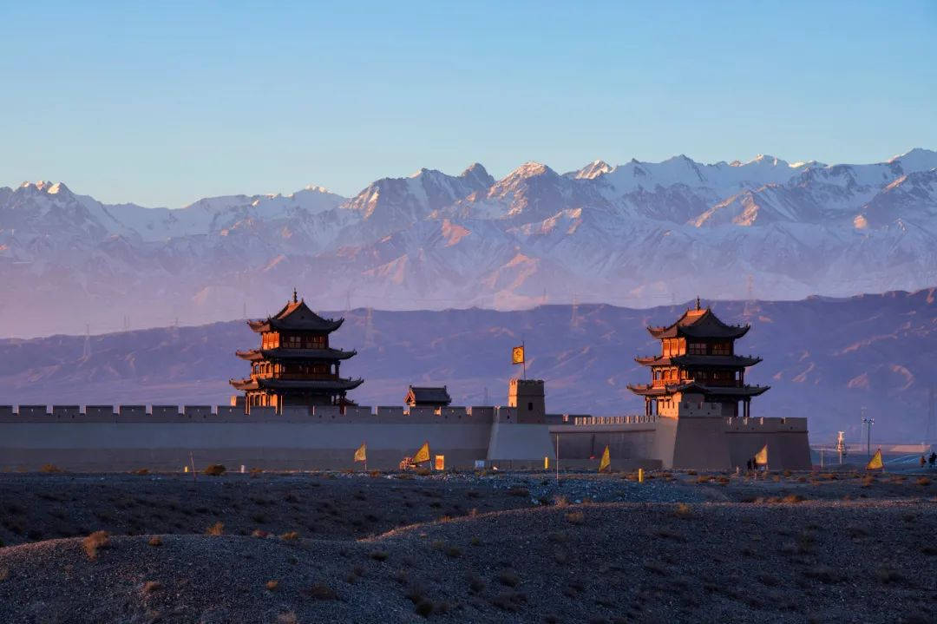

Such a landmark significance of the great building, now has gradually disappeared, there are many places that have fallen, some into ruins, struggling to support the mountain, some have even been turned into mounds. Local surveyors and conservationists say human and the environmental factors are helping to erode what remains, but also by natural factors. Some experts even speculate that parts of the wall will be gone forever in 20 years.

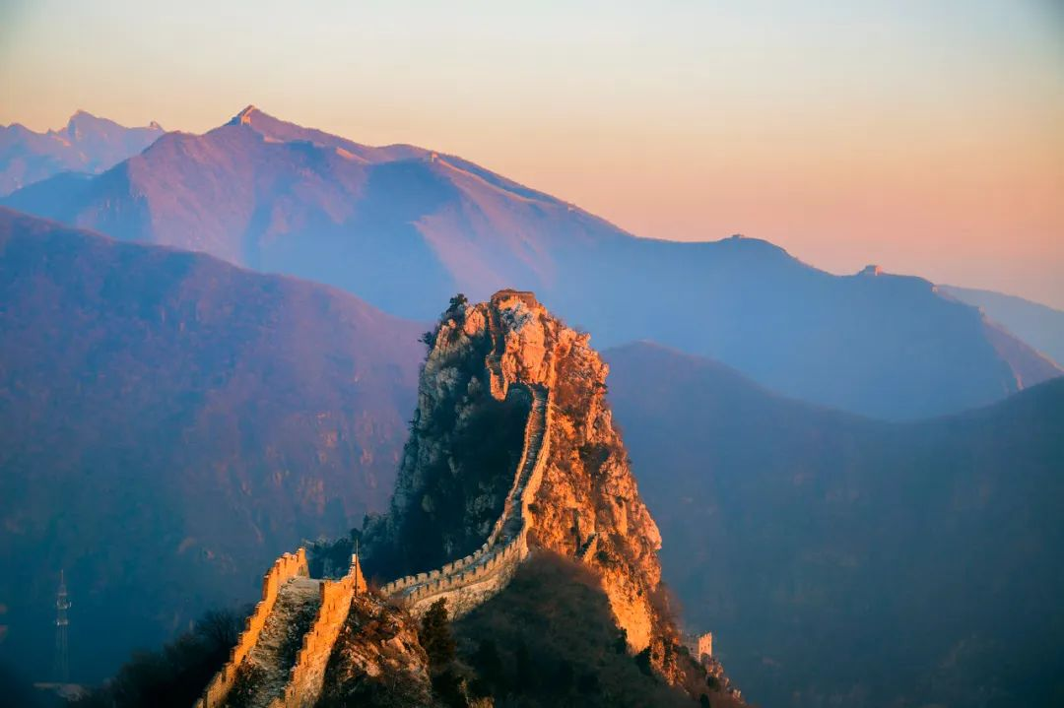

The Great Wall is a Great Wall winding thousands of miles, which is connected with numerous large and small, different forms of enemy towers, watchtowers and ancient castles, and so on. Since it is a wall, it has the function of dividing. There are many differences between the walls and the walls. Inside the wall is the magnificent Central Plains dynasty, farming culture, outside the wall is the rough and bold court and fierce nomadic culture; inside the walls were steady infantry; beyond the walls were the raiding horsemen; inside the walls was an agricultural economy with strong handicrafts; outside the walls is a rugged, natural nomadic economy; the wall to the low plains, the wall is mostly for the plateau desert... The people inside the wall want to expand, the people outside the wall want to invade, out and in between, there is a drama of thousands of years.

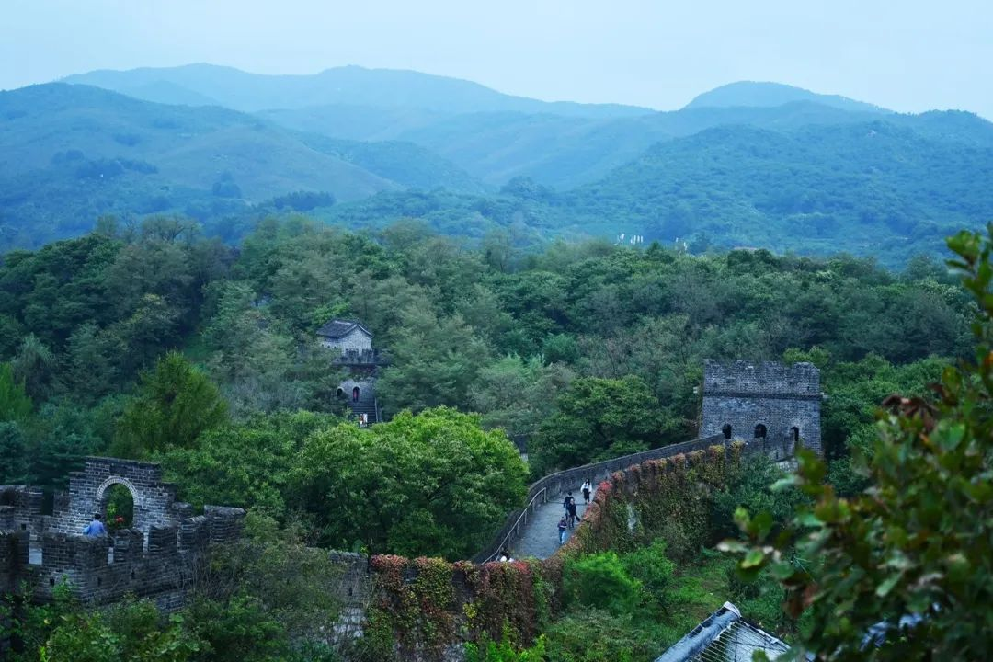

In most people's eyes, the Great Wall should be like the Badaling scenic spot, majestic, straight, long and winding. But those walls are actually only a small part of the entire Great Wall of China. The Ming Dynasty wall, which is best known to the public, is 8,851.8 kilometers long. The artificial wall is 6,259.6 kilometers long, excluding more than 2,000 kilometers of natural passages. At present, the preservation condition of the more than 6000 kilometers of the Great Wall is not optimistic, less than 10% of the preserved proportion, 30% of the disappeared proportion. The reasons for the disappearance of the Great Wall include wind and rain erosion, man-made destruction, maintenance and management, etc. It is not uncommon for the Ming Dynasty Great Wall brick with high cultural value to be stolen, dismantled and sold... Today, the Great Wall is listed as one of the world's 100 most endangered sites.

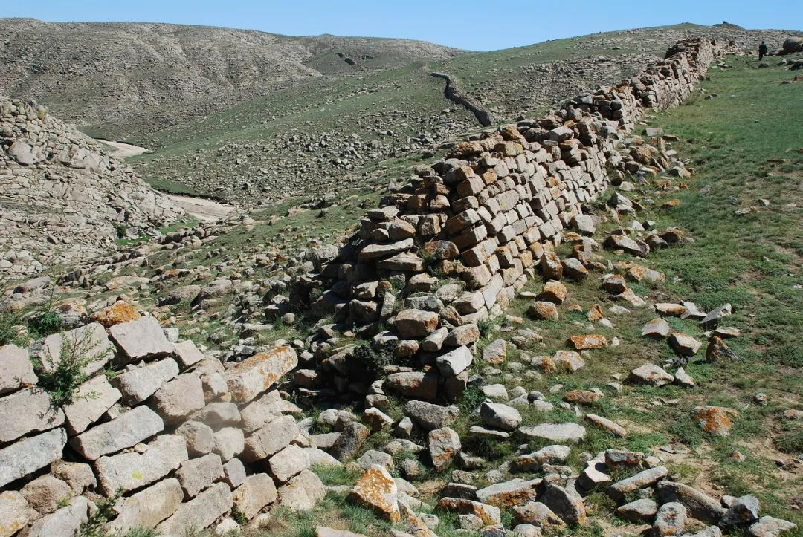

The Great Wall is indeed difficult to protect and manage. Exposed to rain, snow, wind and frost, it is more fragile than ordinary collectible cultural relics. It is impossible to repair and reinforce all kinds of unnatural contacts, and it is more vulnerable to damage than ordinary ancient structures. The lack of capital, technology and manpower, the poverty along the Great Wall, is also the Great Wall protection problem.

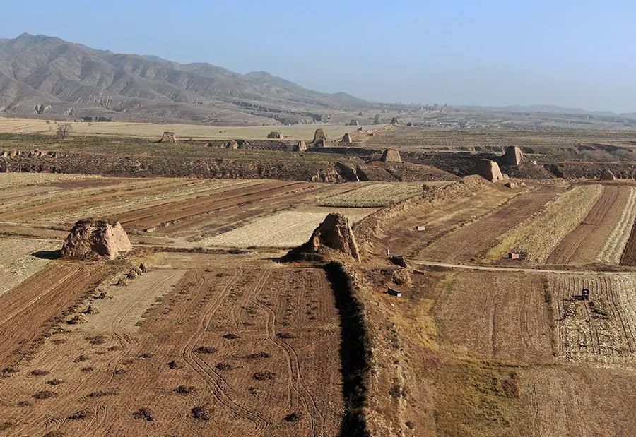

The destruction of the Great Wall has always existed, the destruction of natural forces such as earthquakes, floods, snow, wind, sand and so on. The Ming Great Wall generally has earth walls and stone walls covered with brick walls. Many stone walls and brick walls around Beijing are the most essential and solid part of the Great Wall. Nowadays, it is relatively better preserved. Plant growth is also serious damage to the wild Wall in Beijing, which has a lot of rain in summer.

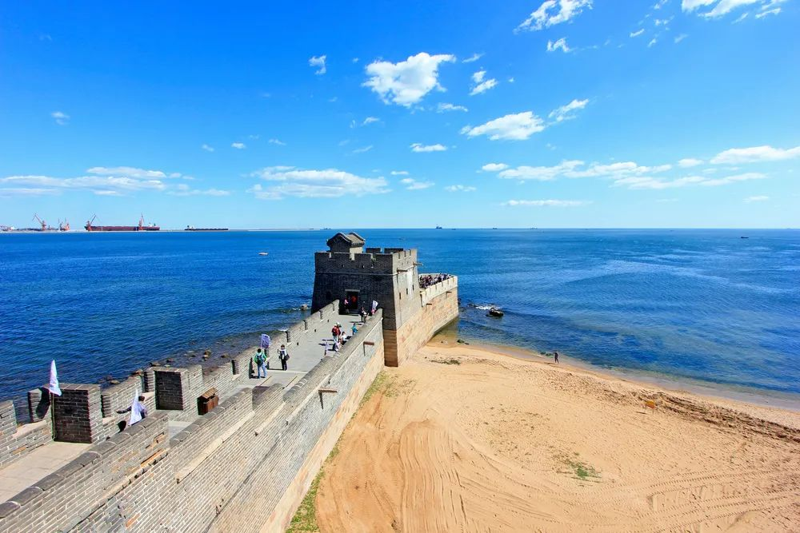

When it comes to the destruction of the Great Wall by human activities, it has been since the fall of the Ming Dynasty that the Great Wall lost its defensive significance and lacked management and maintenance. In order to facilitate transportation, openings on the Great Wall began to be made in the Qing Dynasty. With the rapid development of New China, roads were built everywhere and there were too many examples of tearing down the wall and even the whole Guan Cheng. It is not unusual for villages around the Great Wall to use bricks as free building materials, due to poverty, the helplessness of their homes being destroyed, and the madness of the 1960s and 1970s, or perhaps a combination of various factors.

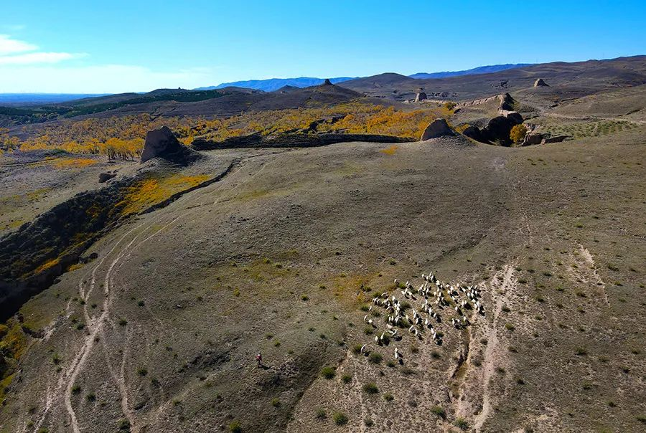

Most of the Great Wall is in a state of imminent disappearance, especially the ancient Warring States, Qin and Han dynasties, Northern Wei and Northern Qi. Large-scale vandalism is now rare, but despite the difficulty, the Great Wall is constantly being reinforced and maintained, and these efforts need to be constantly replenished with fresh blood, arousing people's desire to preserve this huge relic.

Reference

### [VICE News](https://www.vice.com/en/contributor/vice-news)(2015).[Close to a Third of China’s Great Wall Has Perished](https://www.vice.com/en/article/pa4d5y/close-to-a-third-of-chinas-great-wall-has-perished).Retrieved from

### <https://www.vice.com/en/article/pa4d5y/close-to-a-third-of-chinas-great-wall-has-perished>